Project

#Read in the data.   
candy<-read.csv("Candy - Data.csv", header = TRUE)  
head(candy)

## competitorname chocolate fruity caramel peanutyalmondy nougat  
## 1 100 Grand 1 0 1 0 0  
## 2 3 Musketeers 1 0 0 0 1  
## 3 One dime 0 0 0 0 0  
## 4 One quarter 0 0 0 0 0  
## 5 Air Heads 0 1 0 0 0  
## 6 Almond Joy 1 0 0 1 0  
## crispedricewafer hard bar pluribus sugarpercent pricepercent winpercent  
## 1 1 0 1 0 0.732 0.860 66.97173  
## 2 0 0 1 0 0.604 0.511 67.60294  
## 3 0 0 0 0 0.011 0.116 32.26109  
## 4 0 0 0 0 0.011 0.511 46.11650  
## 5 0 0 0 0 0.906 0.511 52.34146  
## 6 0 0 1 0 0.465 0.767 50.34755

#Creating Linear Regression model.  
lnmodel<-lm(candy$winpercent ~ . -competitorname, data = candy)  
#This gives the coefficient values.  
summary(lnmodel)

##   
## Call:  
## lm(formula = candy$winpercent ~ . - competitorname, data = candy)  
##   
## Residuals:  
## Min 1Q Median 3Q Max   
## -20.2244 -6.6247 0.1986 6.8420 23.8680   
##   
## Coefficients:  
## Estimate Std. Error t value Pr(>|t|)   
## (Intercept) 34.5340 4.3199 7.994 1.44e-11 ***  
## chocolate 19.7481 3.8987 5.065 2.96e-06 ***  
## fruity 9.4223 3.7630 2.504 0.01452 *   
## caramel 2.2245 3.6574 0.608 0.54493   
## peanutyalmondy 10.0707 3.6158 2.785 0.00681 **   
## nougat 0.8043 5.7164 0.141 0.88849   
## crispedricewafer 8.9190 5.2679 1.693 0.09470 .   
## hard -6.1653 3.4551 -1.784 0.07852 .   
## bar 0.4415 5.0611 0.087 0.93072   
## pluribus -0.8545 3.0401 -0.281 0.77945   
## sugarpercent 9.0868 4.6595 1.950 0.05500 .   
## pricepercent -5.9284 5.5132 -1.075 0.28578   
## ---  
## Signif. codes: 0 '***' 0.001 '**' 0.01 '*' 0.05 '.' 0.1 ' ' 1  
##   
## Residual standard error: 10.7 on 73 degrees of freedom  
## Multiple R-squared: 0.5402, Adjusted R-squared: 0.4709   
## F-statistic: 7.797 on 11 and 73 DF, p-value: 9.504e-09

This residual standard error is the square root of the variance. Standard error is very similar.

This R-squared subtracts the residual error from the variance.

Adjusted R-Squared normalizes Multiple R-Squared by considering how many samples you have and how many variables you are using

#Creating Logistic Regression model.  
lgmodel<-glm(candy$chocolate~.-competitorname,family = "binomial", data = candy)

## Warning: glm.fit: fitted probabilities numerically 0 or 1 occurred

#This give the summary of the coeffienti values.  
summary(lgmodel)

##   
## Call:  
## glm(formula = candy$chocolate ~ . - competitorname, family = "binomial",   
## data = candy)  
##   
## Deviance Residuals:   
## Min 1Q Median 3Q Max   
## -1.72224 -0.17612 -0.02787 0.01954 2.57898   
##   
## Coefficients:  
## Estimate Std. Error z value Pr(>|z|)   
## (Intercept) -10.29370 4.12040 -2.498 0.01248 *   
## fruity -6.75305 2.20462 -3.063 0.00219 **  
## caramel -1.85093 1.66750 -1.110 0.26700   
## peanutyalmondy -4.11907 2.98175 -1.381 0.16715   
## nougat -16.74818 3520.13323 -0.005 0.99620   
## crispedricewafer 14.98331 4725.35051 0.003 0.99747   
## hard 1.83504 1.80742 1.015 0.30997   
## bar 19.06799 3520.13379 0.005 0.99568   
## pluribus 0.22804 1.45457 0.157 0.87542   
## sugarpercent 0.12168 2.07707 0.059 0.95329   
## pricepercent 1.76626 2.24816 0.786 0.43208   
## winpercent 0.23019 0.08593 2.679 0.00739 **  
## ---  
## Signif. codes: 0 '***' 0.001 '**' 0.01 '*' 0.05 '.' 0.1 ' ' 1  
##   
## (Dispersion parameter for binomial family taken to be 1)  
##   
## Null deviance: 116.407 on 84 degrees of freedom  
## Residual deviance: 25.802 on 73 degrees of freedom  
## AIC: 49.802  
##   
## Number of Fisher Scoring iterations: 19

Null deviance shows how well the response variable is predicted by a model that includes only the intercept

Residual deviance shows how well the response variable is predicted with inclusion of independent variables

#Predict the values and also to check the accuracy of the model.  
res <- predict(lgmodel,candy,type = "response")  
#confusion matrix  
table(ActualValue = candy$chocolate, PredictedValue = res > 0.5)

## PredictedValue  
## ActualValue FALSE TRUE  
## 0 47 1  
## 1 2 35

Confusion matrix: actual value is values from data set and predicted values is from the predicted values.

#accuracy  
(47+35)/(47+1+2+35)

## [1] 0.9647059

To calculate accuracy which is correct number of instances over total number of instances. This give the accuracy

require(ROCR)

## Loading required package: ROCR

#define the ROCRPrediction and ROCRPerformance variables, this is used to plot a graph.  
acuracyPD = prediction(res,candy$chocolate)  
acuracyPF <- performance(acuracyPD,"tpr","fpr")

Tpr - true positive rate

Fpr - false positive rate  
#plotting the graph  
plot(acuracyPF, colorize = TRUE,print.cutoffs.at = seq(0.1,by=0.1))

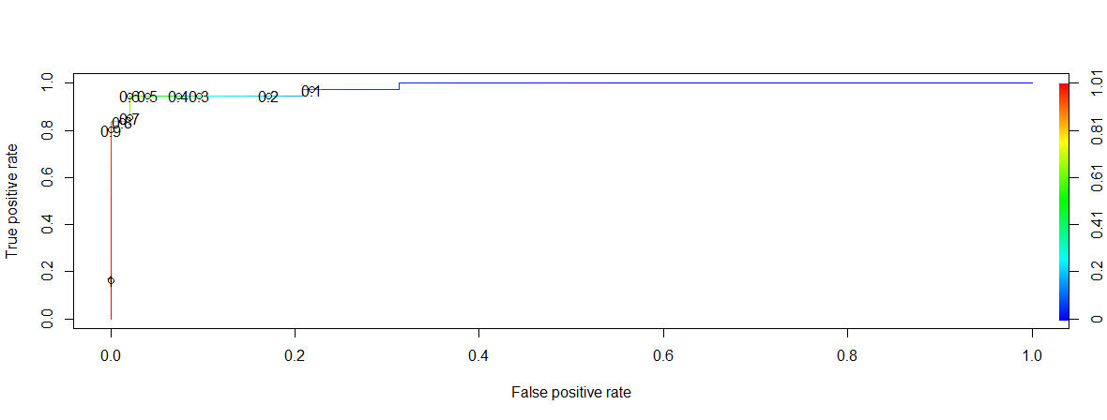

This above graph shows most of the values have less False Positive rate and high true positive rate. This explains the accuracy of the predictions.

In the similar way as mentioned above, there are few other variables which can be considered as dependent variable, which is based on the coefficients in the summary of linear regression model.

#Creating Logistic Regression model for fruity.  
lgmodel1<-glm(candy$fruity~.-competitorname,family = "binomial", data = candy)

## Warning: glm.fit: fitted probabilities numerically 0 or 1 occurred

#This give the summary of the coeffient values.  
summary(lgmodel1)

##   
## Call:  
## glm(formula = candy$fruity ~ . - competitorname, family = "binomial",   
## data = candy)  
##   
## Deviance Residuals:   
## Min 1Q Median 3Q Max   
## -2.31356 -0.00015 0.00000 0.37786 1.87302   
##   
## Coefficients:  
## Estimate Std. Error z value Pr(>|z|)   
## (Intercept) -1.80206 2.08682 -0.864 0.38784   
## chocolate -4.89569 1.57889 -3.101 0.00193 **  
## caramel -3.34322 1.49252 -2.240 0.02509 *   
## peanutyalmondy -19.69040 3645.42314 -0.005 0.99569   
## nougat 0.08994 6118.66419 0.000 0.99999   
## crispedricewafer -16.15216 4832.04683 -0.003 0.99733   
## hard 1.32752 1.08925 1.219 0.22294   
## bar -17.98457 3792.23776 -0.005 0.99622   
## pluribus -0.84050 1.09153 -0.770 0.44129   
## sugarpercent 0.62164 1.59447 0.390 0.69663   
## pricepercent 1.52698 2.04288 0.747 0.45478   
## winpercent 0.07850 0.04819 1.629 0.10332   
## ---  
## Signif. codes: 0 '***' 0.001 '**' 0.01 '*' 0.05 '.' 0.1 ' ' 1  
##   
## (Dispersion parameter for binomial family taken to be 1)  
##   
## Null deviance: 116.880 on 84 degrees of freedom  
## Residual deviance: 38.914 on 73 degrees of freedom  
## AIC: 62.914  
##   
## Number of Fisher Scoring iterations: 19

#Predict the values and also to check the accuracy of the model.  
res1 <- predict(lgmodel1,candy,type = "response")  
#confusion matrix  
table(ActualValue = candy$fruity, PredictedValue = res1 > 0.5)

## PredictedValue  
## ActualValue FALSE TRUE  
## 0 41 6  
## 1 3 35

#accuracy  
(41+35)/(41+3+6+35)

## [1] 0.8941176

require(ROCR)  
#define the ROCRPrediction and ROCRPerformance variables, this is used to plot a graph.  
acuracyPD <- prediction(res1,candy$fruity)  
acuracyPF <- performance(acuracyPD,"tpr","fpr")  
#plotting the graph  
plot(acuracyPF, colorize = TRUE,print.cutoffs.at = seq(0.1,by=0.1))

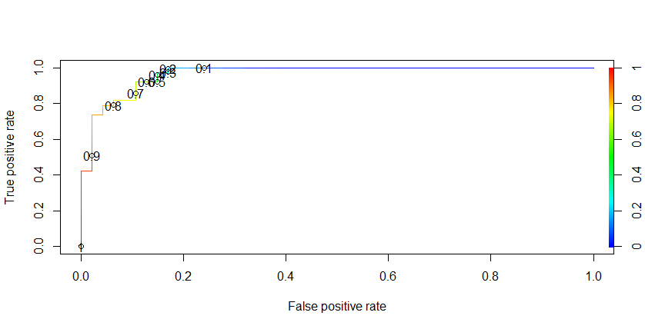

#Creating Logistic Regression model for peanutyalmondy.  
lgmodel2<-glm(candy$peanutyalmondy~.-competitorname,family = "binomial", data = candy)

## Warning: glm.fit: fitted probabilities numerically 0 or 1 occurred

#This give the summary of the coeffient values.  
summary(lgmodel2)

##   
## Call:  
## glm(formula = candy$peanutyalmondy ~ . - competitorname, family = "binomial",   
## data = candy)  
##   
## Deviance Residuals:   
## Min 1Q Median 3Q Max   
## -1.30088 -0.43467 -0.00006 0.00000 2.67591   
##   
## Coefficients:  
## Estimate Std. Error z value Pr(>|z|)   
## (Intercept) -5.38613 2.30768 -2.334 0.0196 *  
## chocolate -1.70693 1.56131 -1.093 0.2743   
## fruity -19.45599 2552.30613 -0.008 0.9939   
## caramel -1.02308 1.02425 -0.999 0.3179   
## nougat 0.62718 1.37196 0.457 0.6476   
## crispedricewafer -1.90396 1.42227 -1.339 0.1807   
## hard -15.59314 3606.56686 -0.004 0.9966   
## bar -0.40264 1.58635 -0.254 0.7996   
## pluribus -0.37066 1.32482 -0.280 0.7796   
## sugarpercent -0.10079 1.76974 -0.057 0.9546   
## pricepercent 2.87643 2.37264 1.212 0.2254   
## winpercent 0.08498 0.04029 2.109 0.0349 *  
## ---  
## Signif. codes: 0 '***' 0.001 '**' 0.01 '*' 0.05 '.' 0.1 ' ' 1  
##   
## (Dispersion parameter for binomial family taken to be 1)  
##   
## Null deviance: 76.057 on 84 degrees of freedom  
## Residual deviance: 43.485 on 73 degrees of freedom  
## AIC: 67.485  
##   
## Number of Fisher Scoring iterations: 19

#Predict the values and also to check the accuracy of the model.  
res2 <- predict(lgmodel2,candy,type = "response")  
#confusion matrix  
table(ActualValue = candy$peanutyalmondy, PredictedValue = res2 > 0.5)

## PredictedValue  
## ActualValue FALSE TRUE  
## 0 67 4  
## 1 5 9

#accuracy  
(67+9)/(67+4+5+9)

## [1] 0.8941176

require(ROCR)  
#define the ROCRPrediction and ROCRPerformance variables, this is used to plot a graph.  
acuracyPD <- prediction(res2,candy$peanutyalmondy)  
acuracyPF <- performance(acuracyPD,"tpr","fpr")  
#plotting the graph  
plot(acuracyPF, colorize = TRUE,print.cutoffs.at = seq(0.1,by=0.1))

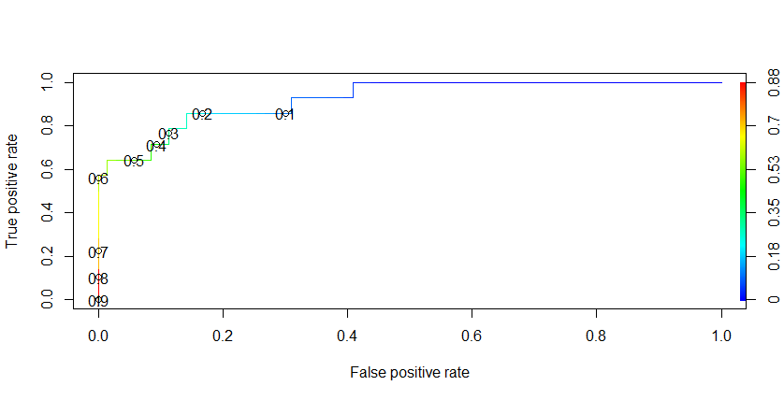

for Chocolate:

#accuracy  
(47+35)/(47+1+2+35)

## [1] 0.9647059

for Fruity:

#accuracy  
(41+35)/(41+3+6+35)

## [1] 0.8941176

for Peanutyalmondy:

#accuracy  
(67+9)/(67+4+5+9)

## [1] 0.8941176

From the above comparison among different accuracies of different variables, the accuracy is more for chocolate. From that we can draw the conclusion for my research question that the candy with more chocolate has the highest demand.

**Reason for selecting these algorithms:**

Is this a Fruit or a Vegetable? These kinds of questions are answered by Classification Algorithm.

Is this weird? These questions are with patterns, and answer by Anomaly Detection Algorithm.

How much or how many? These are quantifiable these are tackled by Regression algorithms.

How is this organized? This is dealt with clustering Algorithm’s

What should I do Next? these types of questions are answer in Reinforcement Learning.

**RATTLE DECISION TREE:**

Implementation of Decision tree by using Rattle:

install.packages("rattle")

library(rattle)

install.packages("tibble")

library(tibble)

install.packages("bitops")

library(bitops)

rattle()

install.packages("RGtk2")

library(RGtk2)

after running these libraries that rattle environment has popped up.

But to get the answer for my research question what the best candy is. Have a column which says the winpercent of each candy. With the help of that we can find best candy with successful variable which is chocolate. As you can see in the dataset. Let us see top 10 winpercent candies, all then has the chocolate variable as 1 which means those candy contains that ingredient.

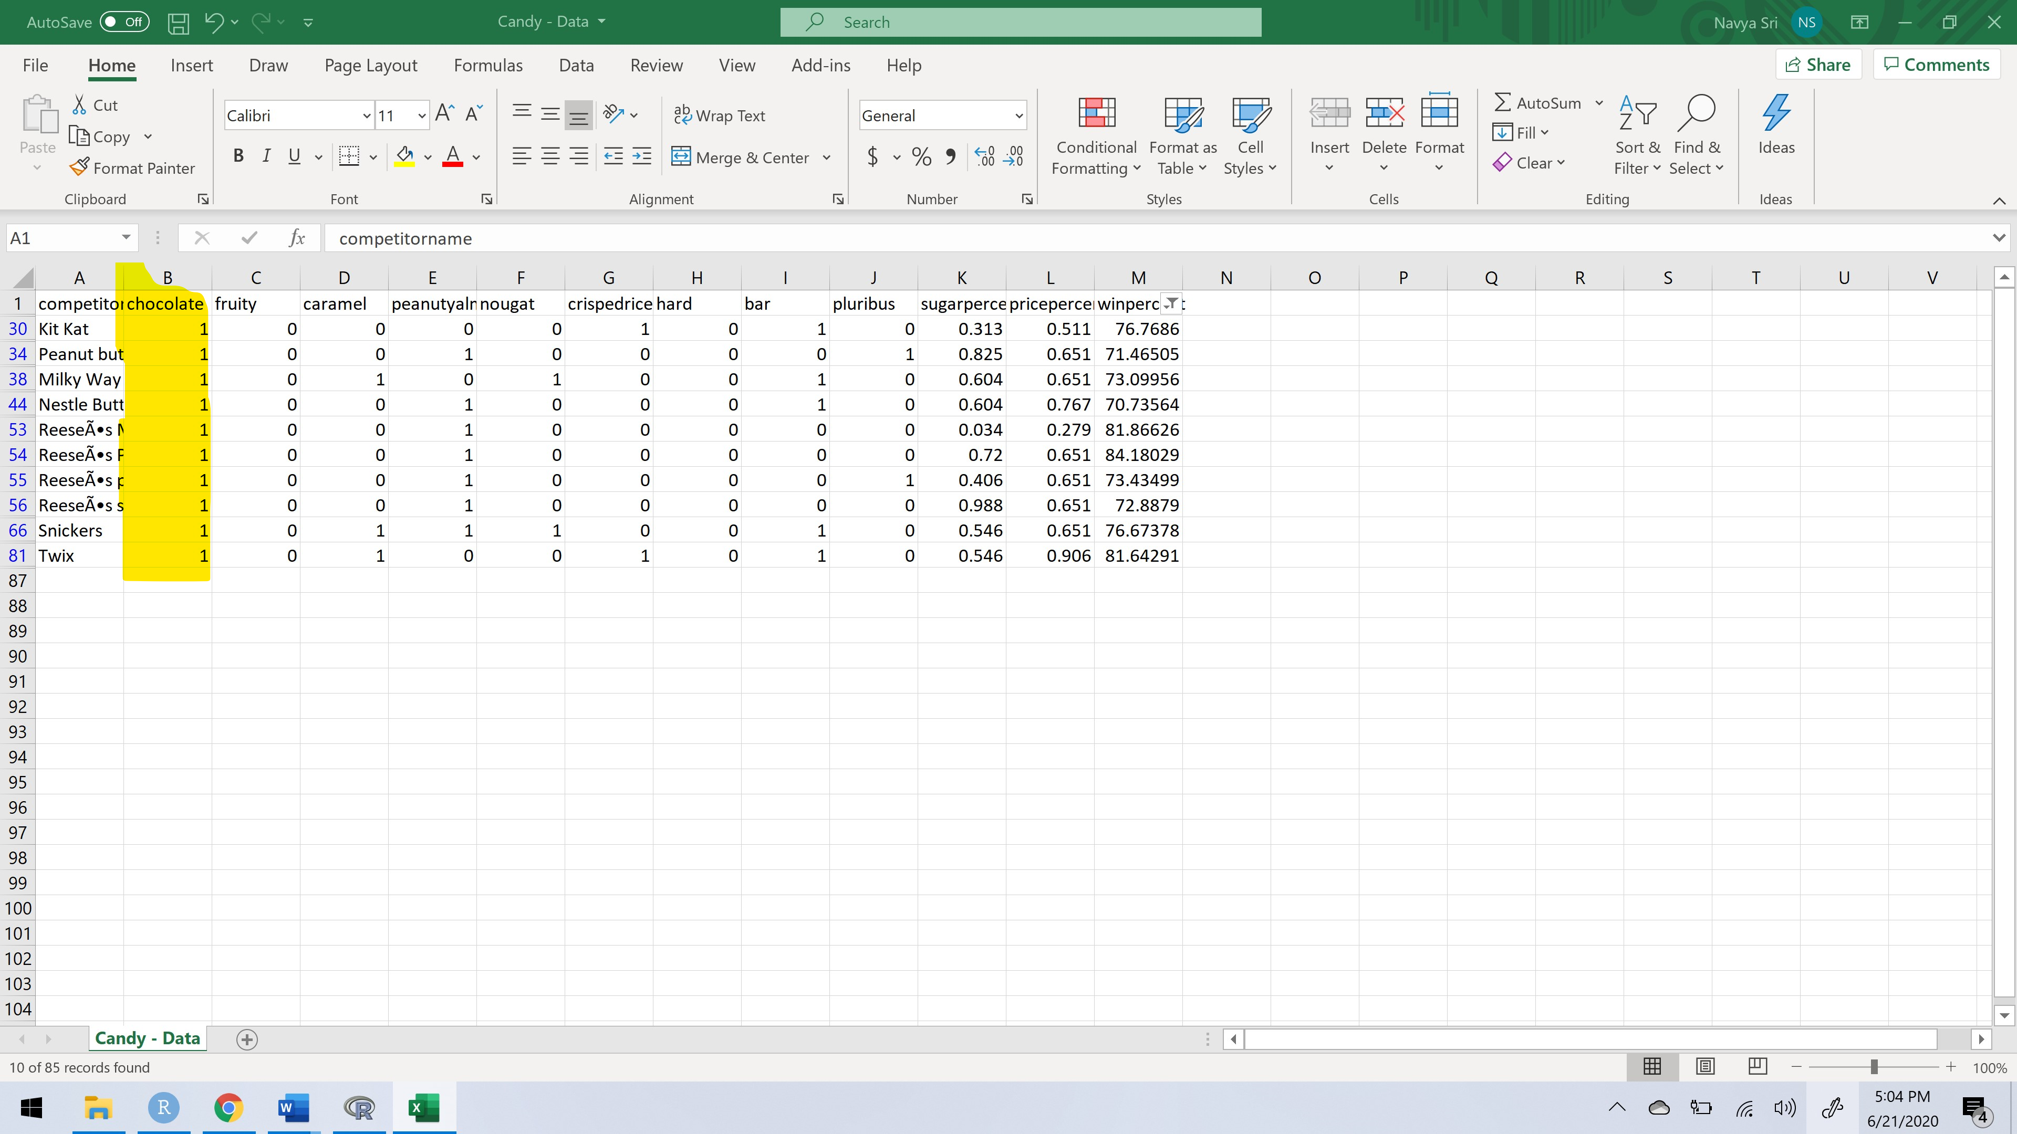

So, lets build the tree with winpercent as the target and compitetorname as the ident.

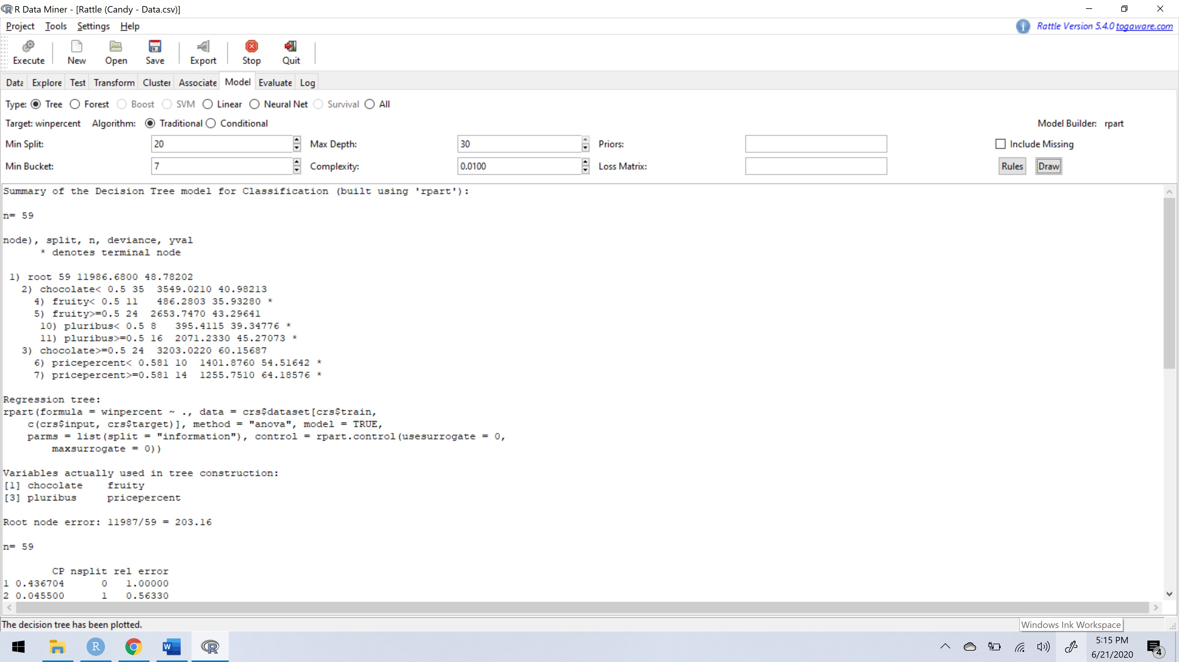

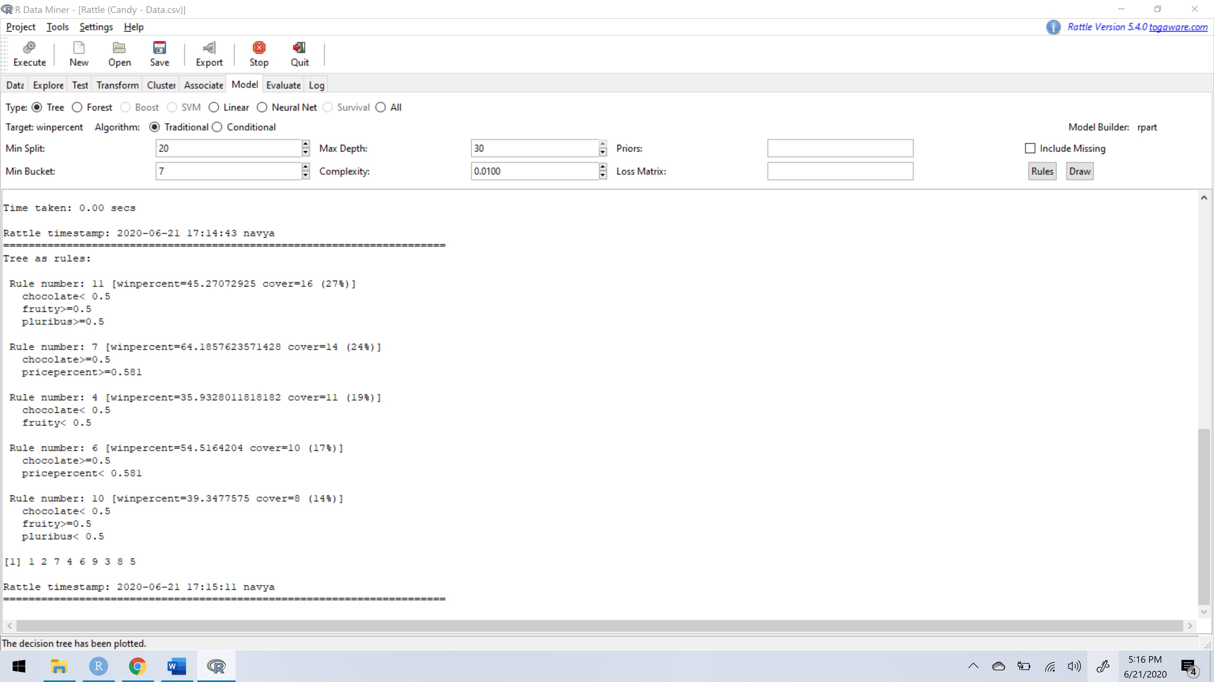

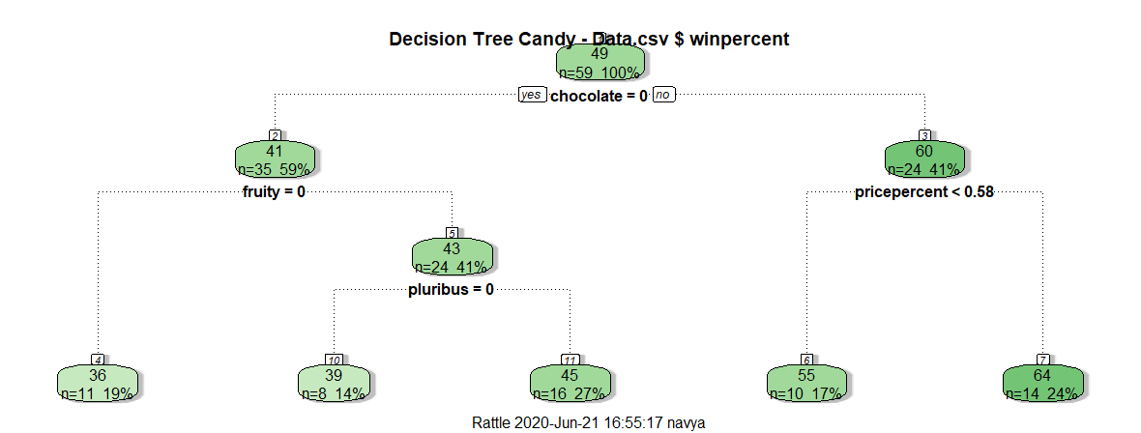

From this tree also we can draw that having chocolate has the dark green which means that has the maximum winpercent. But when compared with the linear and logistic regression models and decision tree using Rattle, I feel the regression models is apt as we can calculate the accuracy of the predicted model compare it with the other variables and find the best candy.

To answer my research question “what is the best candy?”, as my model suggests having the variable chocolate give the candy company profits. So, I think the candies which has chocolate ingredient are the best candies.